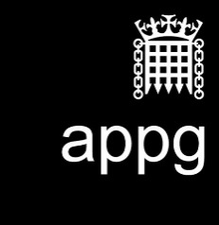

All-Party Parliamentary Media Group
Annual General Meeting: 29th June 2018, Dining Room A, Palace of Westminster

Attendees: Rosie Cooper MP (Chair); Lord Gordon of Strathblane; John Gorgan MP ; Baroness Howe; Lord McNally; Ian Paisley MP; John Penrose MP; Jim Shannon MP: Baroness Thornton; Lord Tyler; Vicky Ford MP; Baroness Ludford; Bill Wiggin MP; Stephen Timms MP; Chi Onwurah MP; Lord Birt; Lord Stevenson; Lord Clement-Jones; Sir William Cash MP; Nic Dakin MP; Lord Low; David Duguid MP; Lord Holmes; Lord Burns.

Stephen Roberts (Assistant to the Clerk)
Chris Whitehouse (Clerk)
Daniel Tor (Associate, Government and Parliamentary Business, Ofcom)
Sharon White (Chief Executive, Ofcom)

Apologies: Baroness Scott

Agenda

1. Approval of annual report

The report was unanimously approved by Members.

2. Approval of financial statement

The Group's financial statement 30 June 2017-29 June 2018 was approved by Members and signed by the Chair.

3. Election of officers

The Group's officers were unanimously elected and are as follows:

Rosie Cooper MP - Chair
Lord Jimmy Gordon of Strathblane - Vice-Chair
Mark Pritchard MP - Vice-Chair
John Nicholson MP - Vice-Chair
Sir Peter Bottomley MP - Honorary Secretary
Sir Roger Gale MP - Honorary Secretary
John Grogan MP – Honorary Secretary

4. Future activity

There was no further activity.

5. AOB

There was no other business.

