Template for income and expenditure statement for All-Party Parliamentary Groups
Name of group: Media Group
Period covered by this statement: 8th March 2023 to 19th March 2024

£
A. Balance brought forward from previous year: | Nil
B. Income received during the year:
i. Membership subscriptions (parliamentarians) | Nil
ii. Monetary donations (including external subscriptions and sponsorship) | Nil
iii. Trading income | Nil
iv. Interest received | Nil
v. Other (please explain) | Nil

TOTAL income | Nil
C. Expenditure during the year:
i. Employment costs (salaries, NI, pensions costs ) | Nil

ii. Costs of contractors and freelance staff | Nil
iii. Visits and events (UK) | Nil
iv. Visits and events (abroad) | Nil
v. Cost of generating income | Nil
vi. Office and communications costs | Nil
vii. Other (please explain) | Nil
TOTAL expenditure | Nil
D. Balance carried forward (A+ total B- total C) | Nil
E. Value of benefits in kind received from each source during the reporting year (in bands of up to £1,500; £1,501-£3,000;  £3,001 to £4,500; £4,501 to £6,000 etc )  Please itemise according to the source and band | Whitehouse Communications Ltd provides benefits in kind to the total value of £42,001 to £43,500 per calendar year and is reimbursed by those organisations listed in the Group’s register entry.

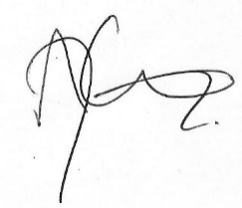
Andy Carter MP: 19th March 2024

